**SpireCapture™ & AMR/AMI System**

Data Viewing Software

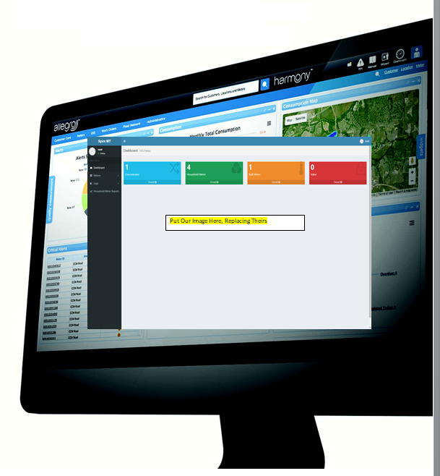

**SpireCapture™ & AMR/AMI Software**

SpireCapture**™** AMI Suite is an open platform, designed to be compatible with nearly every AMI Network on the market today. Its integrated Google® Mapping Tools and advanced Meter Data Management features provide an exceptional environment for managing, reporting, and analyzing advanced metering infrastructure and mobile data solutions. Leveraging the AWS Cloud software cloud, SpireCapture delivers super-fast performance bringing the Internet of Things (IoT) into any sized water utility.

* Addition to SpireCapture is compatible with nearly every billing system to the market and can provide added value and analytics to most Customer Information Systems.

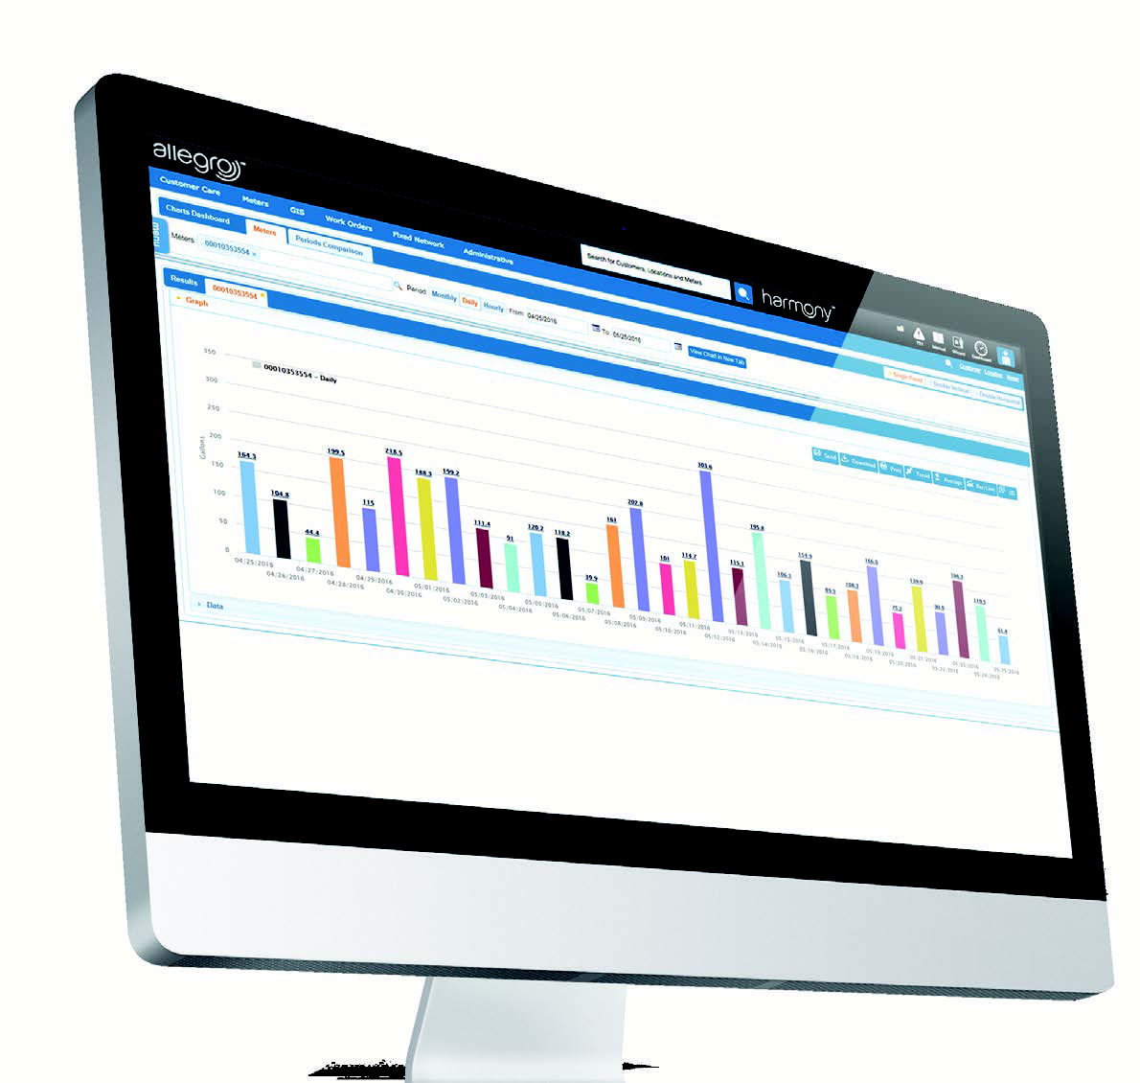

Replace with Our Image

.

Review of system consumption and make sense of it with a wide array of chart and map views. SpireCapture’s Dashboard Overview is designed for easy graphical display Analyze system-wide consumption relative to precipitation to better understand environmental impacts on demand and utilize SpireCapture’s consumption mapping tool for a graphical model of high-and-low consumption regions.

Geo-coordinate meter location information, Google Features such as Street view is an integrated window on the Google Maps. Create District Metered Zones (DMZ) in a few simple clicks with SpireCapture’s analytics allows to easily measure water also included to provide quick loss. With Google Maps in SpireCapture’s GPS Module can inspection of a service can also be used as location find prior to a service call and Mapping tools include: all Google Maps functionality.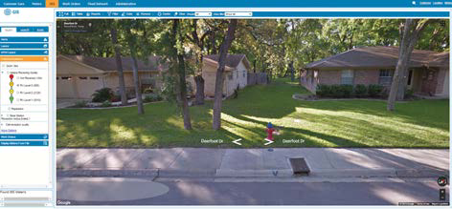

**Google Integration**

**24/7 Monitoring**

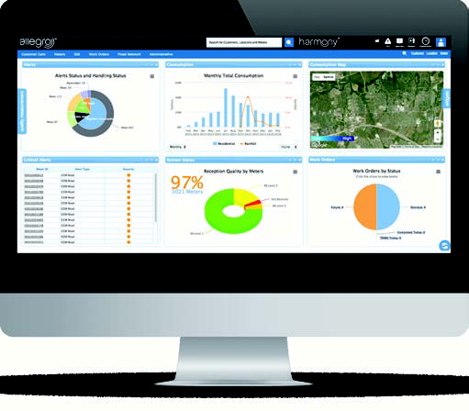With SpireCapture, both water loss and network performance are monitored in real time. Client receive immediate notification of works true two-way communication capabilities with Reads and Data Logging directly from SpireCapture Quickly scroll and zoom through the network to view RF performance and health to preemptively manage issues before they become serious.

**Data Presentation**

**SpireCaptureTM Visibility Views**

• Dynamic 2-way communication with Water Meters and field assets

• Scalable, Microsoft AWS™ Cloud hosted software supports any account size

• SpireCapture supports wide array of 3rd party data integration

• Cross platform SaaS works seamlessly with Windows and Apple environments

• Simple, scalable AMR > AMI technology migration

**SpireCapture™ & AMR/AMI Software**

**Smart Water Meter Data Management + Analytics**

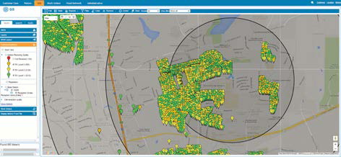

Replace with Our Images!

Replace with Our Image

**SpireCaptureTM Mobile Gateway software**

**SpireCapture’STM Flexible Data Management**

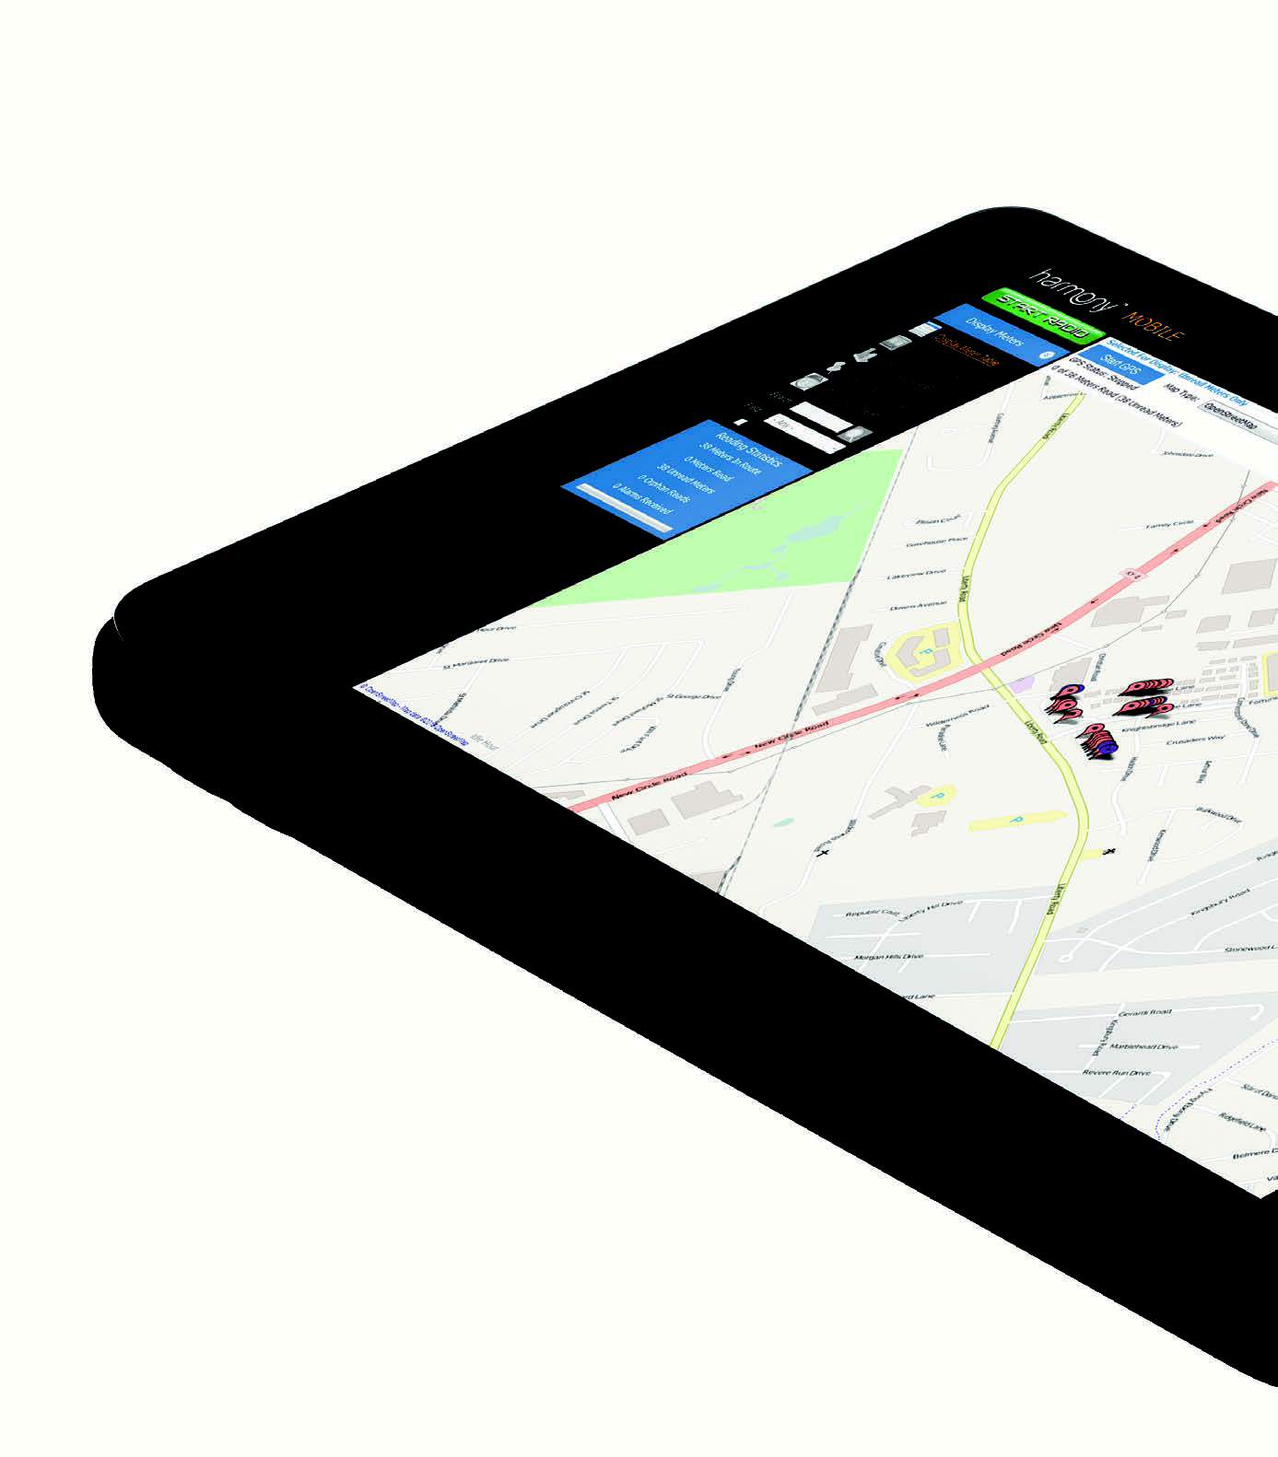SpireCapture’s broad interoperability allows integration between fixed network data and alerts and drive-by route data. The GPS-based Mapping software means that vehicles and personnel are always connected for asset management and inventory controls. Leverage the AWS Cloud Platform for seamless remote communication between

SpireCapture Enterprise Platform and SpireCapture Mobile



**SpireCaptureTM Alerts**

OneDrop and SpiRely meter Alerts can be setup per device. In addition, notifications for theft and tamper are relayed back to the Cloud for analysis and actions. Inactive meters are also identified and queued for inspection.

Leak Alerts and Flow Monitoring assist in reclaiming lost revenue from unaccounted for water and right-sizing for demand.

**Bi Directional Communication**

In-Field, two-way communication allows for minute-by- minute analysis of consumption. Quickly and easily request an on-demand data log to view 15-minute interval reads.

Remote programming of Meters and Remote Firmware

Upgrades are also available through SpireCapture Bi Directional.

**SpireCaptureTM Features**

• Data Management is agnostic to technology source flexible, modular software is forward-ready to support future growth in functionality

• Secure offsite AWS cloud-based data redundancy and remote storage

• Customizable analytics reporting and dashboards

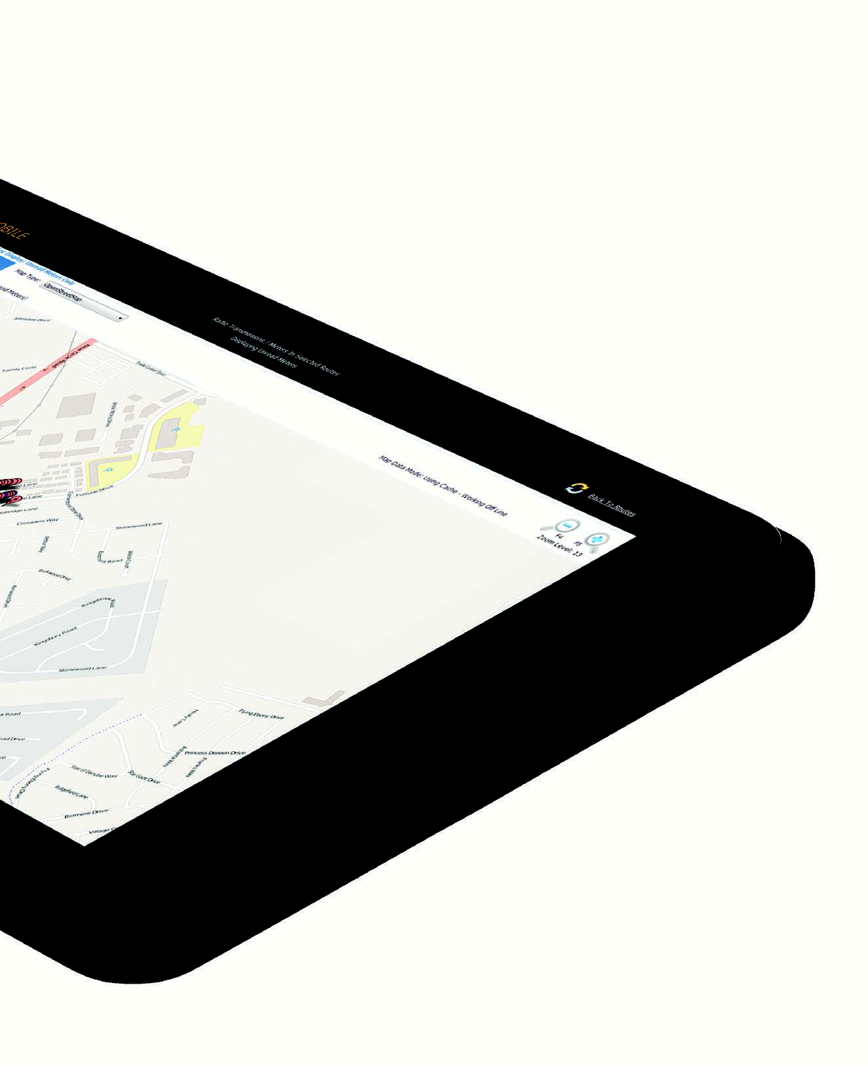

Replace with Our Images

OneDrop and SpiRely providing solutions provider specializing in advanced digital water metering, and data delivery

OneDrop and SpiRely portfolio provides customers with a new and innovative smart water technologies continues to expand in support of today’s dynamic water utility business environment, and the water department ’s rapidly evolving role within a Smart City strategic planning.

Available in Android, the SpireCapture Web Portal puts the power of the Online Portal in you hand.

**Smart Phone Web Portal**

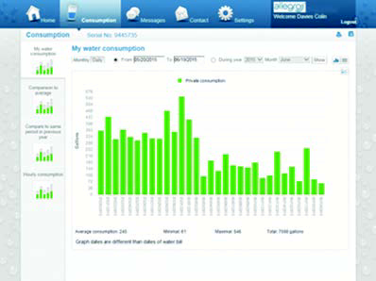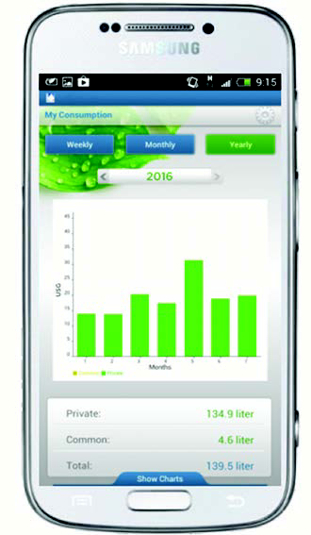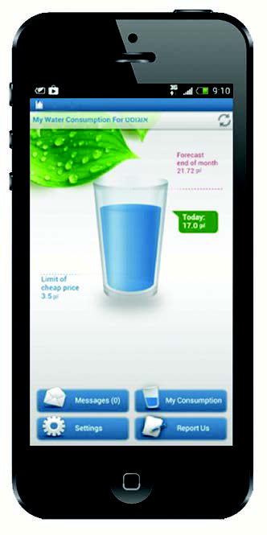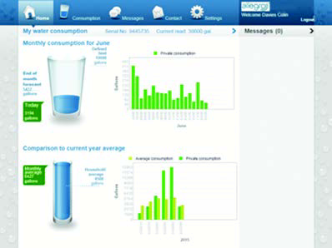

**SpireCaptureTM Mobility**

Replace with Our Images

**Intently Left Blank For Booklet Printing**



**Spiremt.COM**

**Address**

249 Cedar Hill Street Marlborough,  
MA 01752 USA

**Phone number**

Sales : 1-888-738-0188 (Toll Free)

Support : 1-888-738-0188 (Toll Free), 1-978-263-7100 opt 2

General : 1-978-263-7100

**E-mail address**

Sales : Sales@SpireMT.com

Support : Support@SpireMT.com

General : Solutions@SpireMT.com